CURRICULUM VITAE
Of
SYED MOHAMMAD RAKIB

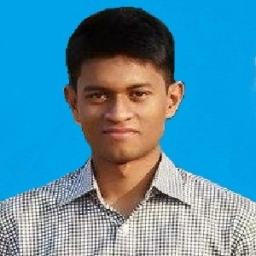

House#58 , Road#11, Sector#13, Uttara, Dhaka-1230

Mobile : 01521210745
E-mail : syedmohammadrakib@gmail.com
Professional Objective:
To work in an environment where professionalism and responsibility are of prime concern and that will provide future opportunities for growth, development, and to use my skills and experience that I have acquired in my academic education.

Academic Background:

Bachelor of Science (B.Sc. in Information Technology, 4 years):
Institution : Jahangirnagar University
Passing year : 2019 (Expected)
Subject : Information Technology

Higher Secondary School Certificate (H.S.C):
Institution : Uttara High School & College, Uttara, Dhaka.
Passing year : 2014
Result : GPA 5.00
Group : Science
Board : Dhaka
Secondary School Certificate (S.S.C):
Institution : Uttara High School & College, Uttara, Dhaka.
Passing year : 2012
Result : GPA 5.00
Group : Science
Board : Dhaka

Language Proficiency:
Bengali – Good command over writing, speaking and reading.
English – Good command over writing, speaking and reading

Computer Literacy:
Microsoft Office (Word, Excel, PowerPoint) .

Personal Information :

Name : Syed Mohammad Rakib

Father’s Name : Syed Abdus Salam

Mother’s Name : Syeda Firoza Begum

Permanent Address : Village : Lahuria, P.O : Kaliganj, P.S : Lohagara, District : Narail.
Date of Birth : August 03, 1996.
Marital Status : Unmarried
Nationality : Bangladeshi
Religion : Islam

Signature : _______________________

